D1_Nihar_84066

ASSIGNMENT 12

1. D1_nihar_84066>select * from CUSTOMERS where Rating>=any(select Rating from CUSTOMERS where Snum in(select Snum from SALESPEOPLE where Sname='Serres'));
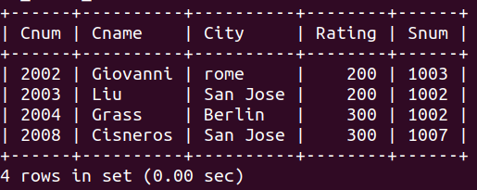

2. D1_nihar_84066>select Sname from SALESPEOPLE where (snum,city)!=all(select snum,city from CUSTOMERS);

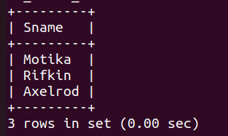

3. D1_nihar_84066>select * from ORDERS where Amt> any(select Amt from ORDERS where Cnum in (select Cnum from CUSTOMERS where city="London"));

